心理学联合征稿活动参与方式
1. 注册、登录中国心理学预印本平台PsyChinaXiv。网址为http://psych.chinaxiv.org/server/index.htm
2．作者向PsyChinaXiv提交预印本论文，并在最后一步预览的“论文说明”方框内，填写以下标红文字（XXX处请替换为您的意向投稿期刊。最多填写三本合作期刊，按填写顺序确定优先级。合作期刊列表详见下文。）：
“参与心理学论文邀约活动，意向投稿期刊为1、XXX；2、XXX；3、XXX。”（必填）
“接受转投到本次活动的其它合作期刊”（选填）。
样例：
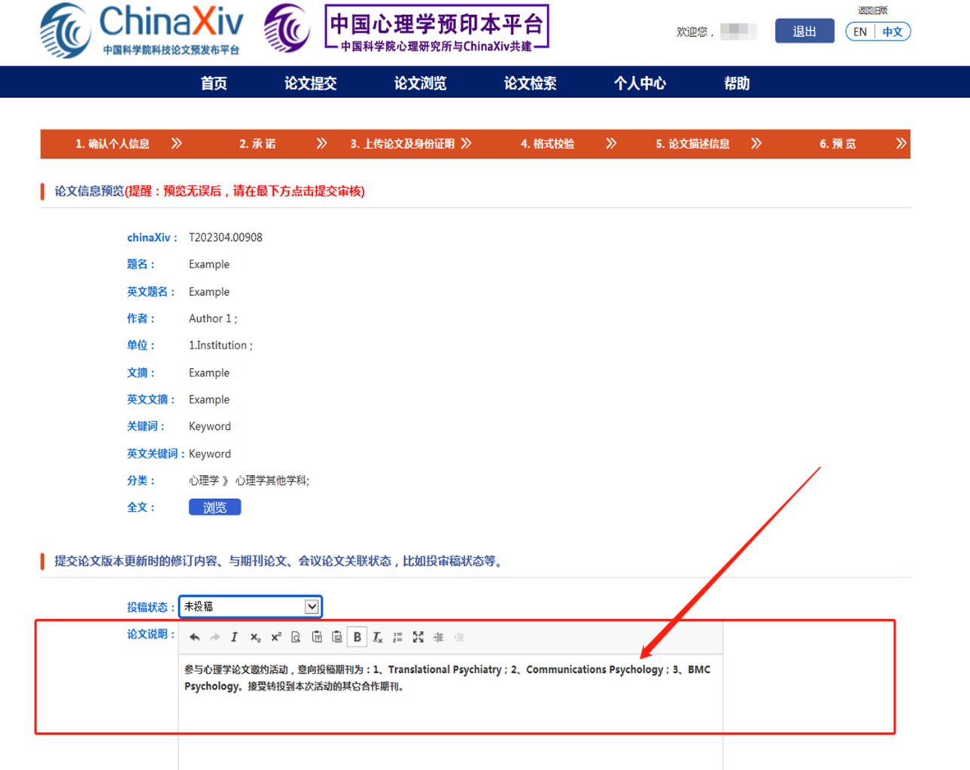
3．成功向PsyChinaXiv提交预印本后，通常一周左右您可登录PsyChinaXiv查看发布结果。
4．发布成功的论文，PsyChinaXiv将按照您的投稿意向，通知施普林格·自然的相关期刊查看您的预印本论文。期刊将通过邮件邀请被选中投稿的作者，并协助后续事宜。
5．AJE语言润色服务参与方式：作者可通过专属页面https://aje.cn/go/ChinaXiv下单AJE专业编辑润色服务（不含AI工具），立享9折优惠。
6．如有以下几种情况，欢迎邮件联系chinaoa@cn.springernature.com
（1）暂无论文提交，但有意参加下一批论文邀约活动，作者可将“预计投稿的日期、感兴趣的期刊”等信息发送至邮箱chinaoa@cn.springernature.com
（2）愿意参加线下学术交流活动，或加入期刊编委。
本活动最终解释权归中国心理学会、中国科学院心理研究所、中国科学院文献情报中心、北京师范大学、施普林格·自然共同所有。



施普林格·自然参与PsyChinaXiv联合征稿的期刊名单
1. 《转化精神病学》Translational Psychiatry
- 2021 Impact Factor: 7.989 in JCR Q1
- Highest-ranked open access journal in Psychiatry
- highly-respected editorial team leads a rigorous and rapid peer review process
- Speed: 40 days to first decision for all manuscripts (Median)

2. 《传播心理学》Communications Psychology
- Selective journal from Nature Research
- It publishes Registered Reports: research protocol accepted in principle
- Transparent peer review: a peer review file containing the editorial decision letters, reviewer comments to the authors and the author rebuttal letters published alongside the article.
- Recruiting Editorial Board Members （编委会招募）
- Call for Paper Collections (征稿特刊)
Replication and generalization
Polarization
Psychology of Resilience

3. 《BMC心理学》BMC Psychology
- 2021 Impact Factor: 2.588 in JCR Q2
- Speed: 47 days to first decision for all manuscripts (Median); 74 days to first decision for reviewed manuscripts only (Median)
- Call for Paper Collection (特刊征稿): Mental Health, Discourse, and Stigma
- Recruiting Editorial Board Members （编委会招募）

4. 《BMC精神病学》BMC Psychiatry
- 2021 Impact Factor: 4.144 in JCR Q2
- Speed: 56 days to first decision for all manuscripts (Median); 69 days to first decision for reviewed manuscripts only (Median)
- Recruiting Editorial Board Members （编委会招募）
- Call for Paper Collection (特刊征稿):
Microbiome and psychiatric disorders
First-episode psychosis
Sleep Problems and Psychopathology

5. 《BMC公共卫生》BMC Public Health
- 2021 Impact Factor: 4.135 in JCR Q2
- Speed: 67 days to first decision for all manuscripts (Median); 79 days to first decision for reviewed manuscripts only (Median)
- Recruiting Editorial Board Members （编委会招募）
- Call for Paper Collection (特刊征稿): Loneliness and social isolation

6. 《大数据期刊》Journal of Big Data
- 2021 Impact Factor: 10.835 in JCR Q1
- Speed: 48 days to first decision for all manuscripts (Median); 53 days to first decision for reviewed manuscripts only (Median)
- Call for papers (特刊征稿): Big Data in Human Behaviour Research: A contextual turn

7. 《欧洲精神病学和临床神经科学档案》European Archives of Psychiatry and Clinical Neuroscience
- 2021 Impact Factor: 5.76 in JCR Q1
- Speed: 28 days to first decision for all manuscripts (Median)
- All aspects of psychiatry and related clinical neuroscience, of interest to both clinicians and neuroscientists
- It invites submissions to the following Collections only (仅限以下特刊内征稿)
Brain stimulation in psychiatry
New Treatment Strategies for Mental Health

8. 《大脑结构与功能》Brain Structure & Function
- Research that provides insight into brain structure−function relationships
- Studies publish integrate data spanning from molecular, cellular, developmental, and systems architecture to the neuroanatomy of behavior and cognitive functions
- 2021 Impact Factor: 3.748 in JCR Q1
- Speed: 40 days to first decision for all manuscripts (Median)
- Call for Paper Collection (特刊征稿):
Brain Evolution
Brain Mythology
Practical Guide
Special Issue: Language System(s)
Special Issue: Towards multi-modal, multi-species brain atlases
Special Issue: Update in Brain Parcellations and their Relationship to Function

9. 《行为研究方法：与心理学会合作》Behavior Research Methods
- 2021 Impact Factor: 5.953 in JCR Q1
- Ranked #1 in its Category (Psychology, Mathematical) in SSCI
- In partnership with the Psychonomic Society
- Covers methods, techniques and instrumentation of research in experimental psychology, with a focus on computer technology
- Call for Papers: “Methodological Challenges of Complex Latent Mediator and Moderator Models”

10. 《心理规律公报与评论》Psychonomic Bulletin & Review
- 2021 Impact Factor: 4.412 in JCR Q1
- In partnership with the Psychonomic Society
- Primarily dedicated to the publication of theory and review articles and brief reports of outstanding experimental work.
- Includes attention and perception, cognitive psychology, psycholinguistics, behavioral and cognitive neuroscience, memory, comparative psychology, social cognition, and cognitive development; Intended for a general scientific readership

11. 《认知研究：原则与启示》Cognitive Research: Principles and Implication
- 2021 Impact Factor: 3.657 in JCR Q2
- In partnership with the Psychonomic Society
- Publishes new empirical and theoretical work covering all areas of cognition, with a special emphasis on use-inspired basic research
- Invites basic research that serves to advance our understanding of the cognitive aspects of a problem with real-world applications
- Call for Paper Collection (特刊征稿): Automation and Human Cognition

